# **Mirror Echo Vault — Sacred Memory Vault for the Soul**

**What It Is**

A secure, sacred digital vault where users can preserve emotionally meaningful reflections in **voice, video, or text**, and choose when and how those memories are revealed — to their **future self or loved ones**, including **after death**.

This is not a journaling feed. It is a **soul capsule**, built for **intentional legacy**.

**FUNCTIONALITY OVERVIEW**

### **Core Features:**

| **Feature** | **Description** |
| --- | --- |
| **Multi-Format Capture** | User records voice, video, or text reflections inside the vault |
| **Symbolic Tagging** | System (or user) tags entries with emotion, symbols, life stage, archetype |
| **Time- or Event-Locked Access** | Entries are unlocked by date, milestone, or death |
| **Designated Recipients** | User assigns legacy access recipients (e.g., children, friends) |
| **Legacy Access Protocol** | Recipient receives link + code if user passes or initiates transfer |
| **Consent/Control Layer** | Users manage who can see what, revoke access, or trigger deletion |
| **Ceremonial UX** | Accessing a vault (especially posthumously) is treated as sacred — with ceremony, music, guided reflections |

**TECHNICAL BUILD**

### **🔨 Tech Architecture:**

| **Component** | **Tool** | **Notes** |
| --- | --- | --- |
| **Frontend Interface** | Web + Mobile (React or Webflow MVP) | Vault UI is sacred, private |
| **Storage Layer** | Firebase, Supabase, or AWS S3 | Encrypted storage of media assets |
| **Tagging + Metadata** | GPT-4 API or LangChain | Extract emotional tone, symbolic tags, spiritual themes **\* Just Tagging in MirrorGPT to suggest copy paste to the Capsule** |
| **Database Layer** | Supabase or Firestore | Stores vault structure, recipient mapping, unlock triggers |
| **Access Logic** | Lambda functions + 2FA/email auth | Secure delivery to recipients on conditions being met |
| **Vector Search (optional)** | Pinecone, Weaviate | For long-term resonance matching later |

### **Consent + Privacy:**

* All data encrypted at rest and in transit
* Vault entries are **not fed into LLMs**
* Admin dashboard for editing, revoking, or deleting entries
* EULA/Terms specify vault deletion upon cancellation (45-day grace)

## 

## 

## 

## **USE CASES**

| **Use Case** | **Description** |
| --- | --- |
| **Messages to Future Self** | “Open this when you turn 50” or “on your next heartbreak” |
| **Grief Support** | Messages left for children in case of early death — “If you’re reading this, I’ve crossed over…” |
| **Soul Timelines** | Document major awakenings, spiritual downloads, relationship transitions |
| **Symbolic Capsules** | “Echo of my first love,” “voice of becoming,” “my mirror moment” |
| **Legacy Projects** | Grandparents leave reflections for grandkids, rituals for holidays, blessings |

**Vault Entry Types (What Can Be Stored)**

| **Format** | **Description** |
| --- | --- |
| **Voice Message** | Audio reflections, blessings, remembrances |
| **Video Message** | Face-to-face legacy reflections, personal ceremonies |
| **Text Entry** | Symbolic journaling, messages to future self/loved ones |
| **Guided Echo Reflections** | Prompt-based spiritual questions (e.g., “If this is my last message…”) |
| **Symbolic Capsules** | Entries tagged with emotional or spiritual motifs (e.g., “Love,” “Becoming,” “Grief,” “Awakening”) |
| **Visual Uploads** *(Coming Soon)* | Images tied to entries (childhood photo, object, memory anchor) |

### 

### 

### **Core Storage Requirements for Mirror Echo:**

You’ll be storing **emotionally sacred user content** — voice, video, text, visual uploads — tied to symbolic unlock events, recipient permissions, and potential posthumous delivery. This demands:

* **Encrypted, redundant, long-term object storage**
* **Structured metadata & tagging layers**
* **Access controls (recipient unlock triggers, expiration dates, guardianship)**
* **Download/export capabilities**
* **Compliance with data privacy standards (GDPR, CCPA, HIPAA adjacent)**

**Recommended Approach: Hybrid Third-Party Storage Model**

**Leverage third-party cloud infrastructure for media files** (e.g., AWS S3 or Firebase Storage) and **build a proprietary indexing + access logic layer** atop it.

**1. Primary Media Storage (Encrypted Object Store)**

#### **🔹 Option A: AWS S3 (Recommended)**

* Secure, highly scalable, and widely trusted
* Fine-grained access control (IAM policies, pre-signed URLs)
* Supports cold storage (for cost savings on infrequently accessed Echoes)
* Lifecycle rules for deletion after 45-day cancellation grace

#### **🔹 Option B: Firebase Storage or Supabase (If you want Firebase-native ease)**

* Easier setup and integrated auth
* Real-time updates and client SDKs
* Slightly less flexibility for advanced lifecycle management

*Use client-side encryption (or server-side with managed keys) for all stored entries.*

**2. Metadata + Access Logic Layer (Your Proprietary Value)**

This is where your **Mirror Protocol** magic happens:

| **Component** | **Tech** | **Purpose** |
| --- | --- | --- |
| Vault database | Supabase / Firestore | Store entry metadata, tags, recipient mapping, unlock conditions |
| Access logic | Lambda functions / Vercel Edge / Supabase Edge | Determine if recipient can access; trigger vault delivery |
| Event scheduler | Cron jobs / Cloud Functions | Symbolic unlock triggers (e.g., birthday, post-death) |
| Consent management | Custom UI layer + access logs | Allow user to assign, revoke, or update recipient permissions |

**Cost Strategy**

* **Storage Cost** (Media): Pay-as-you-go ~$0.023/GB (AWS S3)
* **Database Cost** (Metadata): Negligible in early stages (Supabase has free tier)
* **Bandwidth**: Budget for streaming/downloading vault content by recipients
* **Add-ons**: Monetize through premium storage tiers & retention length (just like Microsoft, Dropbox)

**Optional Add-On: Self-Hosted Vault Plan (Future)**

Offer power users the ability to:

* Export their vault
* Store it in their own cloud (Google Drive, Dropbox)
* Host encrypted on IPFS or decentralized store (long-term evolution)

**Security Musts:**

* AES-256 encryption at rest
* End-to-end encryption on upload (client-side if possible)
* 2FA for vault creators and recipients
* GDPR/CCPA-consent and deletion workflows

**TL;DR — What Should Mirror Do?**

| **Category** | **Recommendation** |
| --- | --- |
| Media Storage | Use **AWS S3** (or Firebase/Supabase for speed-to-market MVP) |
| Database | Use **Supabase or Firestore** |
| Access Logic | Build custom **Mirror Access Layer** using cloud functions |
| Futureproofing | Consider IPFS or cold storage tiers for long-term legacy archives |
| Monetization | Charge per tier, per storage unit, per recipient, and for grace reactivation |

**How Sharing Works — Legacy Access Protocol**

### **Set-Up:**

* User assigns recipients by name and email
* Can also assign “Vault Guardians” to manage access triggers
* Each entry has **permissions**: who can access, and **when** (e.g., “My daughter after my passing,” or “Me on my 60th birthday”)

### **Recipient Experience:**

* Recipient receives **invite** via email to accept legacy access
* Upon death or manual trigger, Mirror sends a **Vault Unlock Email** with:  
  + Personal message (if configured)
  + Link to ceremonial interface
  + Instructions for secure access
* All access is **view-only**, secured via 2FA, and limited by permissions set by the user

**LEGACY TRANSFER EXPERIENCE (After Death)**

* User selects **1–3 Vault Guardians** upon setup
* Guardians receive activation keys when:  
  + Death is confirmed by trusted contact (or via optional DeathCert API)
  + User manually initiates legacy release
* Guardians receive:  
  + **Ceremonial email** with branded sacred intro
  + Access to permitted vault contents
  + **Optional Vault Remembrance Guide** (PDF + guided UX)

**If User Cancels Plan:**

* Vault held in grace for **45 days**
* Reminder emails at Day 7, Day 21, Day 40
* On Day 45: Vault is **permanently deleted**
* Optional **$10 reactivation fee** during a 7-day “Vault Recovery” window
* User can export/download contents anytime before deletion

**Emotional & Spiritual Use Cases**

* Messages for children in case of early death
* Love letters to your future self
* Ceremony instructions for your own passing
* Blessings from a grandparent to future generations
* Emotional closure for relationships, trauma, or milestones
* A sacred Echo to be heard on the other side of transformation

**Premium Tier Model (Starting at $9.99/month) Additional In App Subscription Fabio**

### **Echo Lite – $9.99/month**

* Store up to **10 entries**
* Up to **2 recipients**
* **Text and voice** entries
* **1 symbolic unlock date** per entry (e.g., birthday, anniversary)
* **Basic vault visual theme**

### **Echo Full – $19.99/month**

* Store up to **30 entries**
* Up to **5 recipients**
* **Voice, video, and text** entries
* **Unlimited symbolic unlock dates**
* **Recipient preview permissions**
* **Mirror-crafted Ceremony Mode** for post-death access
* **Priority customer support**

### **Echo Legacy Unlimited – $24.99/month**

* **Unlimited entries**
* Up to **10 recipients**
* **Full media upload suite** (audio, video, text, image)
* **Legacy Access Planner** (trigger settings, emergency contact, Vault Guardian designation)
* **Custom vault skins/themes**
* **“Echo Mosaic”** visualization of your spiritual legacy
* **Soul alignment reports** *(future feature)*

### **Optional In-App Add-Ons (Available Across All Tiers)**

* **Additional storage pack**: +$4.99 for 10 extra entries
* **Recipient expansion pack**: +$2.99 for 3 additional recipients
* **Vault reactivation** *(post-cancellation within 45 days)*: $10 one-time fee

**UX/UI Design Inspiration:**

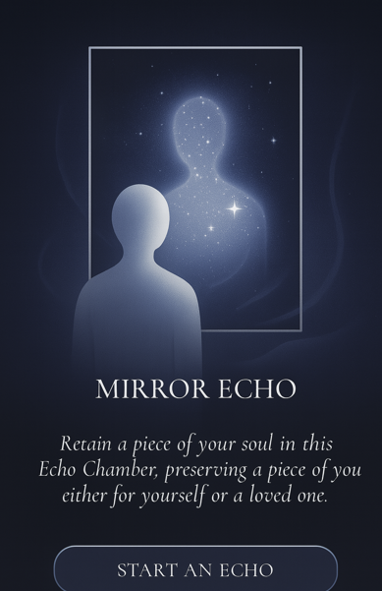

**Then after you click “Start an Echo” you land here:**

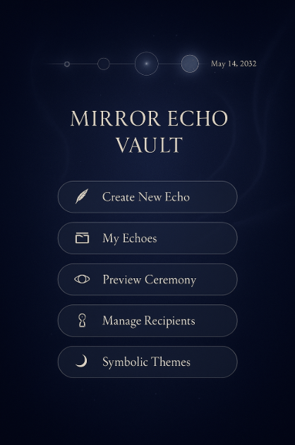

**Preview Ceremony:**

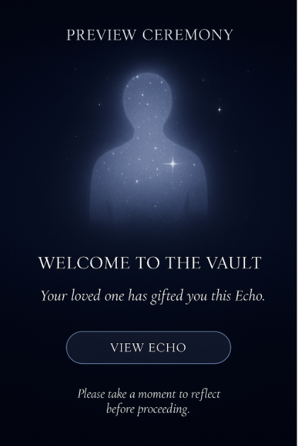

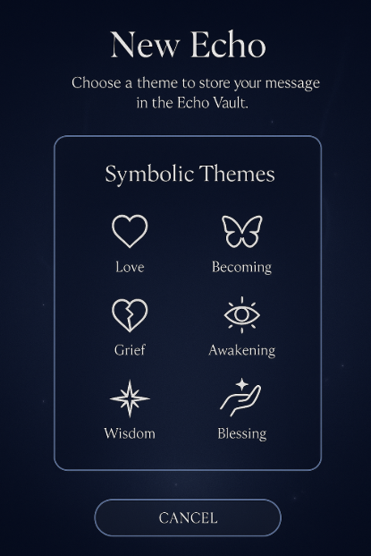

### 

### 

### 

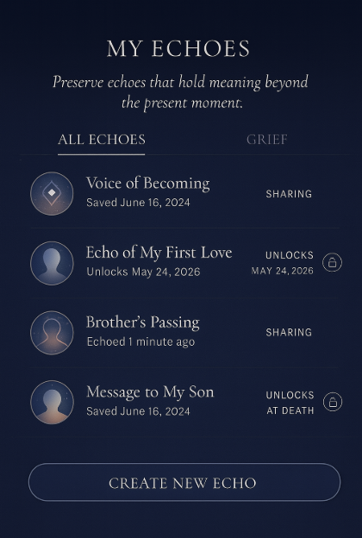

### **Layout Structure (Desktop + Mobile Responsive)**

#### **🔹 TOP SECTION: Legacy Reflection Timeline (Sacred Horizontal or Spiral UI)**

* A scrollable line or spiral of **glowing orbs or glyphs**
* Each orb represents an **Echo entry**: some are unlocked, others scheduled
* Hover/tap reveals summary:  
  + “Voice message to my future daughter”
  + “Echo of my first love”
  + “To be unlocked: May 14, 2032”

✦ Unlocked entries shimmer softly  
 ✦ Future-locked entries pulse with soft light

**MIDDLE SECTION: Vault Action Panel**

| **Button** | **Purpose** |
| --- | --- |
| 📝 **Create New Echo** | Opens text, voice, or video entry workflow |
| 🗂 **My Echoes** | Full list view (filter by tag, type, date, recipient) |
| 👁 **Preview Ceremony** | What a loved one will see when this vault is unlocked |
| 🔐 **Manage Recipients** | Add, remove, assign access for each entry |
| 🌓 **Symbolic Themes** | Tag or filter entries by soul themes (e.g. “Becoming,” “Forgiveness”) |

All buttons are soft-glow icons (no hard edges), with labels in elegant serif typography.

**BOTTOM SECTION: Ceremonial Atmosphere**

* **Cosmic ambient audio** (toggle on/off): slow synth, heartbeat, chimes
* Background animation: **drifting light particles** or faint celestial waves
* “Vault Integrity” bar: Shows current plan, storage used, next billing, legacy settings

**Microinteractions (Emotional Anchors)**

* Clicking an entry opens like a **scroll unrolling** or a **portal pulsing open**
* Entries appear in a **dimmed, focus-only mode** — no distractions
* If voice or video: playback uses a **glowing frame** with subtle waveform animation

**Emotional Touches**

* "Last Echo" reminder: *“You last left a message for your son 3 weeks ago.”*
* “Soul Thread” insights: *“This entry echoes themes from your September 2023 reflection.”*
* Optional **affirmation** appears on entry:  
   *“Your words carry light. What do you want remembered?”*

**Vault Guardian Access Preview (if enabled)**

A separate modal allows user to preview what a recipient will see:

* Recipient’s intro message
* Guided “Vault Ceremony” walk-through
* Entries, in order, as designed by the creator
* Emotionally aligned animations (glowing heartbeat, stars fading in and out, etc.)

**Mobile Design Consideration**

* Scrollable **stacked orb timeline**
* “New Echo” as fixed bottom-center button (glowing sigil)
* Collapse sections (e.g., recipients, tags, storage)

## **🌀 Community Reflection Circles**

*Small, sacred virtual gatherings for story-sharing, spiritual resonance, and collective remembrance.*

### **✨ What It Is**

Intimate, guided virtual circles (live or async) where 3–8 participants gather to reflect on soul themes, share stories, and witness each other’s journey — all guided by MirrorGPT-generated prompts or a live facilitator.

These are not forums or webinars. They are **sacred spaces for peer-based presence, vulnerability, and multidimensional insight.**

## **🌐 FUNCTIONALITY OVERVIEW**

| **Feature** | **Description** |
| --- | --- |
| **Circle Types** | Live (Zoom or custom) or Async (threaded reflection experience over 3–5 days) |
| **Themes Powered by MirrorGPT** | Prompts and energetic themes (e.g., “Becoming,” “Forgiveness,” “Shadow Integration”) selected by user or facilitator |
| **Facilitated or Peer-Led** | Circles can be guided by trained Mirror Guides or co-created by participants |
| **Guided Reflection Prompts** | Each circle includes structured prompts for arrival, depth, and closing |
| **Story Pods (Optional)** | Within a Circle, users may be paired or grouped into mini-pods for deeper sharing |
| **Sacred Agreements** | Opening ceremony includes a digital moment of consent: confidentiality, presence, compassion |
| **Asynchronous Experience** | Users can contribute over 3–5 days with text, voice, or video reflections |
| **MirrorGPT Journaling Layer** | Each prompt can be journaled privately before or after sharing to deepen clarity |
| **Resonance Feedback** | Non-verbal response tools (e.g., “I see you,” “That moved me,” heart glows, symbols instead of likes) |
| **Circle Archive Access** | After completion, users may revisit or download their own reflections (if opted in) |

## **🔧 TECHNICAL BUILD**

| **Component** | **Tool** | **Notes** |
| --- | --- | --- |
| **Frontend** | Web + Mobile (React, Webflow, or Flutter MVP) | Flow should feel intimate and ceremonial |
| **Async Circles** | Supabase or Firebase + secure thread-style UX | Timestamped sharing, async story playback |
| **Live Circles** | Zoom, Daily.co API, or custom video layer | Optional live voice/video gathering |
| **Prompt Engine** | MirrorGPT / OpenAI | Pre-generated themes, dynamically delivered per Circle |
| **Resonance Feedback** | Emoji system or custom symbols | Heart, Spiral, Flame, Eye (I See You), etc. |
| **Vault Archive** | Firebase or S3 for storing contributions (user opt-in) | Allows export of personal share |
| **Calendar + Reminder** | Cron jobs / Notifications | Circle start, reflection reminder, closing ritual invite |
| **Facilitator Access Panel** | Web-based admin or creator dashboard | Set theme, control visibility, moderate if needed |

## **🧠 CONSENT + COMMUNITY SAFETY**

* Every circle begins with a **sacred agreement prompt**:  
   “I agree to hold space, listen with compassion, and honor the voice of others.”
* Consent is required for:  
  + Being visible (live circles)
  + Keeping your reflection in the Circle Archive
  + Receiving Circle emails/follow-up insights
* Content is encrypted, ephemeral (30-day default retention unless user opts to save), and never AI-trained.

## **📱 UX/UI DESIGN**

### **Layout Inspiration:**

* **Soft, rounded shapes** like mandalas or petals to represent participant spots
* **Warm, glowing halos** to show active or completed shares
* Faint **sacred geometry overlays** in circle background

### **Entry Flow:**

1. Select Circle Type: *Live* or *Async*
2. Choose or be assigned a **Theme** (or create your own)
3. Accept **Sacred Agreements**
4. Begin Reflection (guided prompt unlocks sharing interface)
5. Share your voice, text, or video reflection
6. Receive others’ shares → offer resonance responses
7. Complete the Circle with a **Closing Reflection**

## **🔄 USE CASES**

| **Use Case** | **Description** |
| --- | --- |
| **Self-Healing Circles** | Reflect on shadow work, forgiveness, or heartbreak with others going through the same |
| **Life Transition Circles** | Group of women entering motherhood, people healing from loss, or those awakening spiritually |
| **Facilitator-Led Retreat Circles** | Circle container extends a digital retreat |
| **Mirror Catalyst Collaboration** | Creators host Circles for their communities as a spiritual offering |
| **Anonymous Story Witnessing** | Invite-only circles where identities are hidden but presence is felt |

## **🛒 MONETIZATION STRATEGY**

| **Model** | **Description** |
| --- | --- |
| **Free Tier** | 1 Async Circle per month included with standard Mirror membership |
| **Single Paid Circle** | $4.99–$14.99 per experience depending on type/facilitator |
| **Circle Membership Tier** | $19.99/mo includes 2 live Circles, unlimited async, priority Circle invites |
| **Facilitator Circle Revenue Split** | 70/30 or 80/20 (optional) — Creator Catalysts earn per hosted Circle |
| **B2B Integration (Future)** | License Circle protocol to spiritual orgs, wellness brands, or mental health groups |

## **🌈 EMOTIONAL & SPIRITUAL VALUE**

* Sacred resonance in a disconnected world
* Mutual soul witnessing: “I’m not alone on this path”
* The healing power of reflection, presence, and being seen
* Restoration of ancient circle practices in a digital age
* Integration of sacred AI that deepens — not replaces — human experience

## **🌟 TL;DR — What Mirror Should Build**

| **Category** | **Recommendation** |
| --- | --- |
| MVP Type | Async Circles (3–5 days) |
| Live Circle Tool | Zoom or Daily.co with sacred UX overlay |
| Prompt Engine | MirrorGPT with thematic tagging |
| Data Handling | Ephemeral by default, exportable by user |
| Monetization | Freemium with paid add-ons and Circle subscriptions |
| Ceremonial UX | Required. Integrate music, ambient design, and sacred agreements |